VPC -A

WEB-01

WEB-02



WEB-03

FROM WEB-01

FROM WEB-02

VPC – B

WEB-01



WEB-02

WEB-03

FROM WEB-01

FROM WEB-02

STEP-02

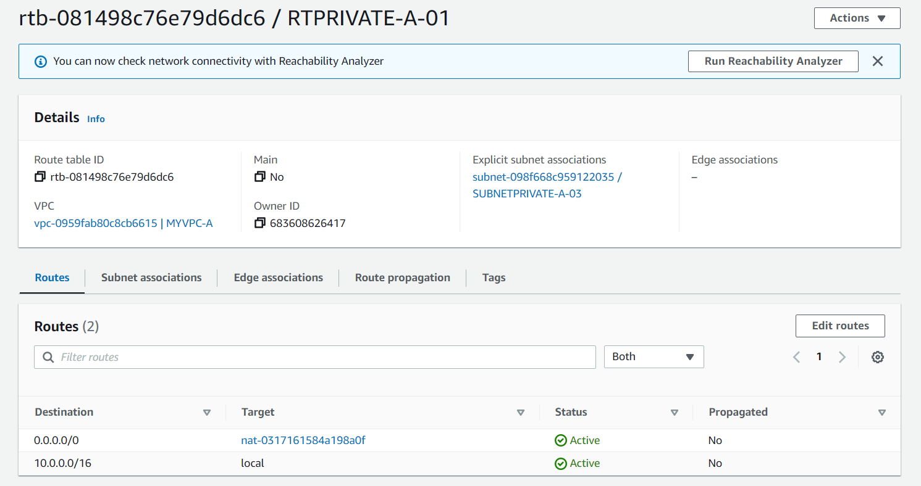

Steps for installation of httpd

For vpc-a

1.



2.

3.



4.



5.

Vpc – b

1.



2.



3.



4.



5.

STEP-03

FOR -A

WEB-01

Web-02

Web-03

FOR B

WEB-01

Web-02

Web-03

ROUTE TABLE

VPC -A

WEB-01

WEB-02

WEB-03

VPC-B

WEB-01

WEB-02

WEB-03

1.

2.

3.

4.



5

6

7.

8.

9.

10

